**Name:** Diego Dias Pereira

**WEBSITE PURPOSE**

1. **Who is the customer?**

Customer is a single person who wants to work as a Freelancer web developer and web designer.

This customer has a few projects to present though their site and their focus are to deliver a responsive website that runs smoothly either in a mobile, tablet or desktop.

1. **Customer needs**

The customer presented a list of demands for their website:

* Create a Logo using their name and surname initials -> D & D
* Asked to add a profile photo
* Pallets color - Light blue, black, grey and white for the background
* Include a button to open their CV in a PDF file
* Background and experience
* Skills
* Testimonials - 3 persons
* The service that they provide
* Portfolio
* Address with a Google Maps Iframe
* Contact me section with their:
  + Address
  + Phone number
  + Email address
  + Website
* Contact Form to contact them
* Footer with a site map, social media (Facebook, Instagram and GitHub)

Customer intend to impact and drag attention from people who are looking for website creation for their business and also for those who already have a website and want to improve it.

Based on this concept I took notes of some tags and keyword to include in the head of the website for SEO: HTML, CSS, Web Developer, WordPress, responsive, mobile, business.

1. **Project evolution**

As per the customer demands and my knowledge in HTML, CSS and frameworks (Bootstrap, jQuery), I found some beautiful HTML and CSS templates to re design the website in <https://html5up.net/> which I highly recommend. However, after a careful search I found the most suitable template in colorlib.com and download it. In the original template model the section “Awards” was replaced to “Testimonials”. I changed the icons on the top, below the header to icons that represents the technologies acquired by the customer (HTML, CSS, Google-SEO and WordPress). Added grow animations effects and transition timing to them.

* I looked up for some nice and friendly fonts-family on Google Fonts and picked up “Poppins”, “Sans-serif” and added it to the body.
* I inserted a Google Maps Iframe to represent the customer address.
* Rewrote the text adapting to the customer’s suggestion.
* Created a beautiful Logo by using canvas.com:

**Image 1:**



* Added a background image on the header with overlay effect, low opacity and parallax effect (Background-attachment: Fixed)
* In the “Contact me” section I changed the icons color to light gray and added a hover effect when the user pass the mouse over the icon changing its color to light blue and rotating it 15° as demonstrated below:

**Image 2:**

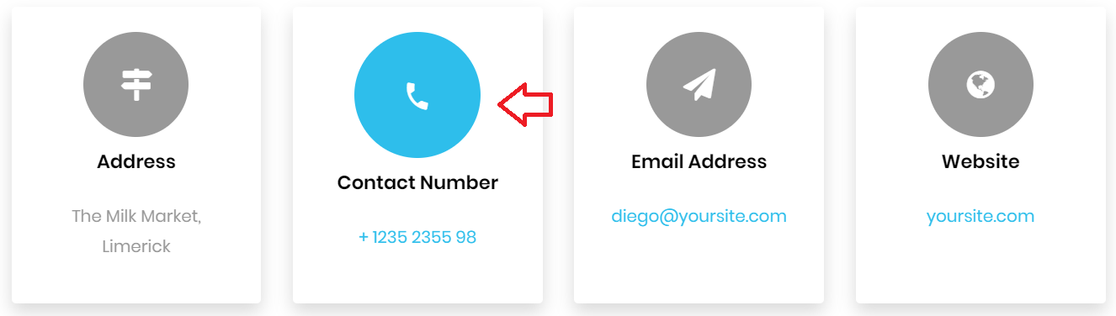

* Also, added hover effect on the links placed in the footer section. When the user pass the mouse over them it changes the color to white as you can see below:

**Image 3:**

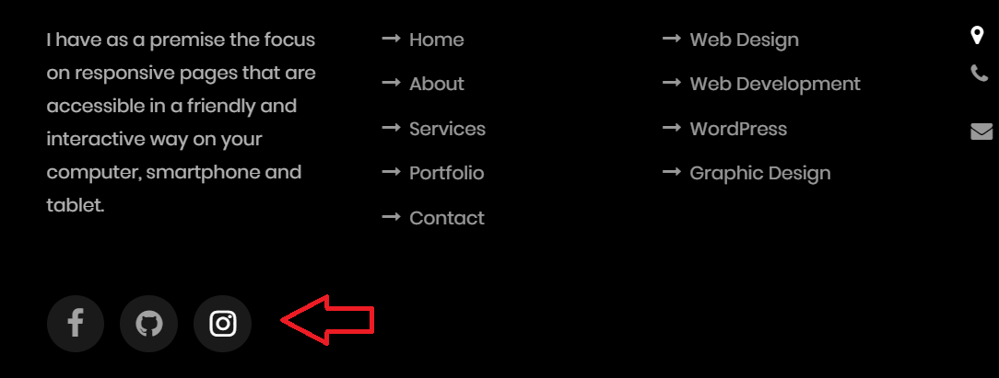

**Image 4:**

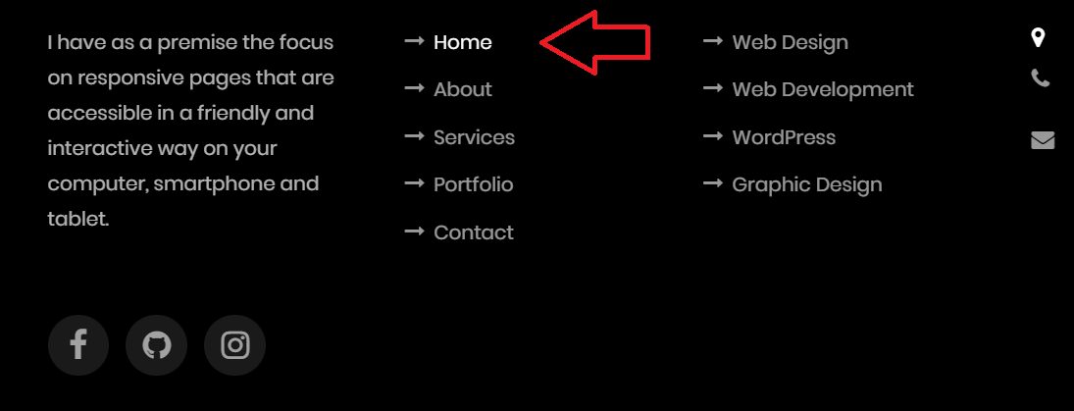

The last part was checking for HTML and CSS code error. I checked the HTML code in HTML validator website, fixed the errors. For the CSS errors check I tested it in CSS Lint. Both HTML and CSS are cleaned and free from errors.

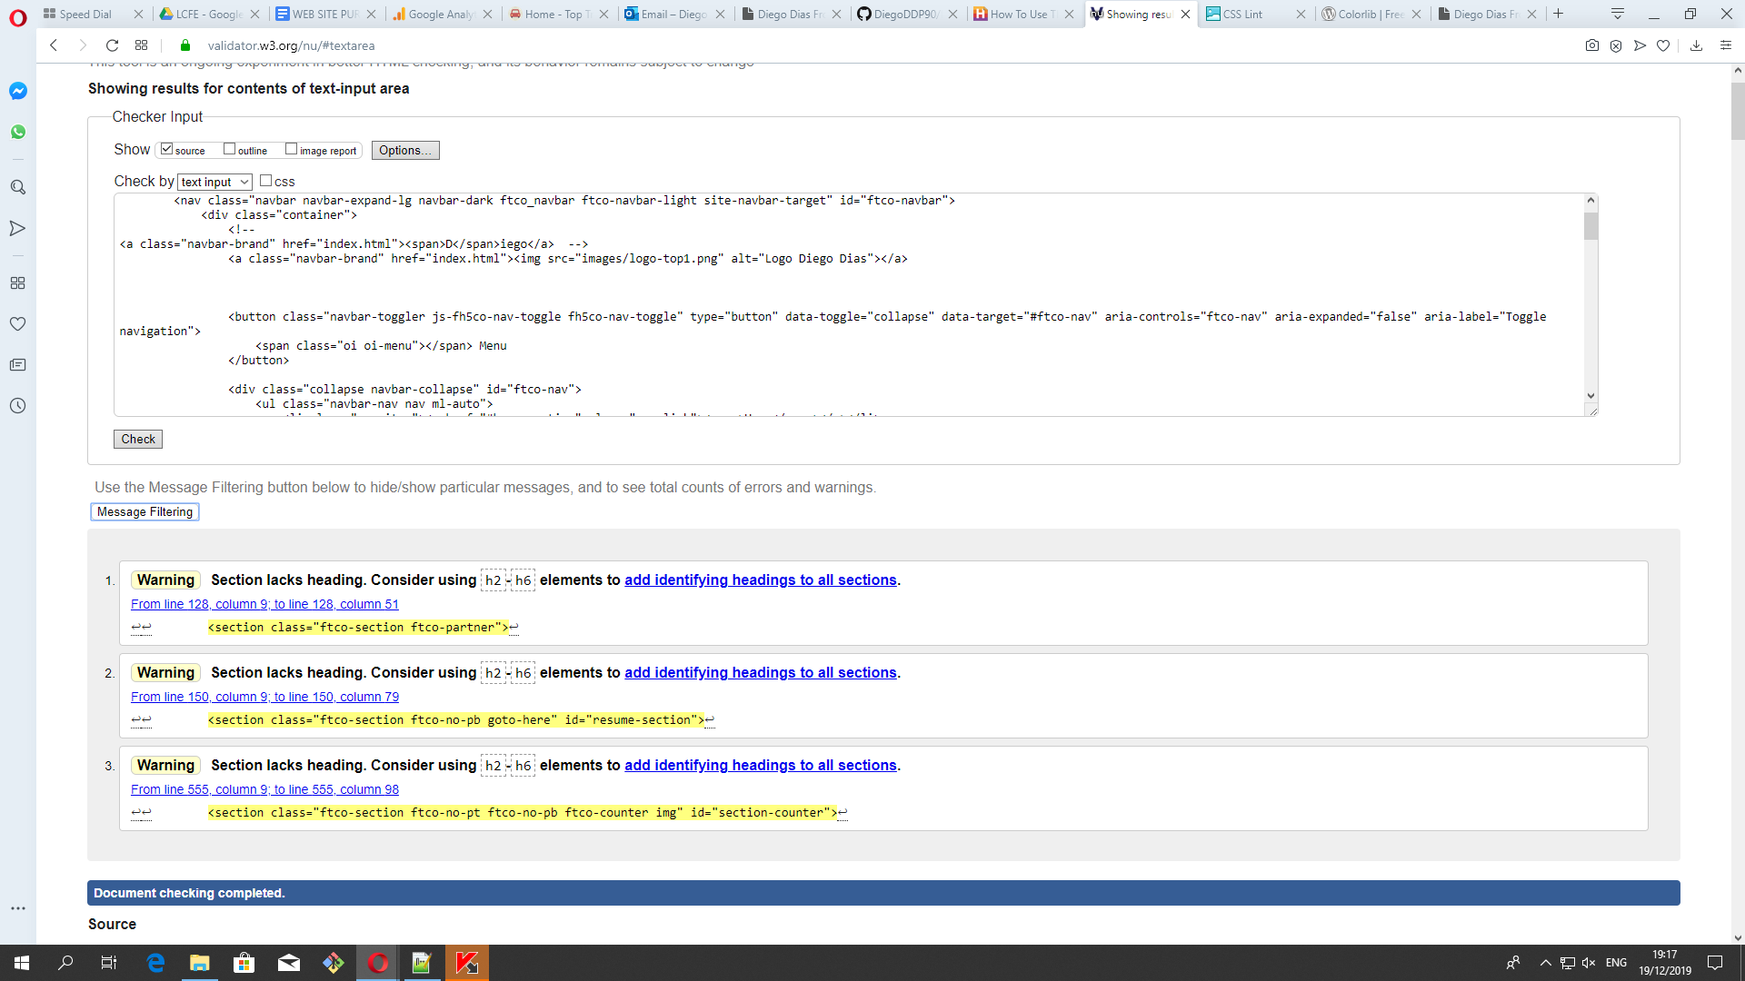

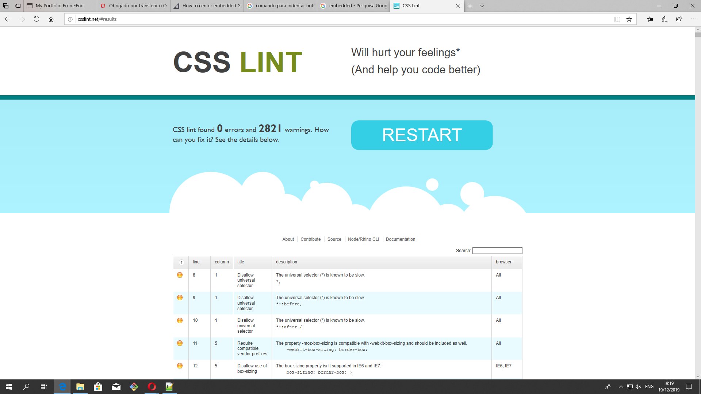

**4. Website Structure:**

Title: Diego Dias Front-End Developer

**LOGO**

Home About Resume Services Portfolio Contact

**Header**

Title – Diego Dias (my name)

|  |  |
| --- | --- |
| A pr Profile picture  Size – 345 x 742 | About me   * Brief introduction * Full name * DOB (Date of birth) * Address * Download CV (Button) |
| ssss |  |

Ic

s

**Icons animated:**

|  |
| --- |
| Mic Html5 CSS3 Google Wordpress |

**Body**

|  |  |
| --- | --- |
| **SIDE MENU**  -EduEEducation  -ExpeExperience  -SkillsSkills  -Awa Testmonials | Educ Education  -  -  -  -  Experience  -  -  -  Skills  Skills  CSS Css HTML WordPress  50% 60% 70% 60%  Awar  -  - |
|  |  |

**Testmonials**

Person 1

Person 2

Person 3

**Services**

|  |  |  |
| --- | --- | --- |
| **Web Design** | **Web Development** | **SEO** |

**My Projects**

|  |  |  |
| --- | --- | --- |
| **Site 1** | **Site 2** | **Site 3** |

|  |  |  |
| --- | --- | --- |
| **Complete Projects** | **Happy Customers** | **Cups of coffee** |

|  |
| --- |
| **Available for Freelancing**  **Button Hire me** |

**Contact me**

|  |  |  |  |
| --- | --- | --- | --- |
| **Address** | **Phone number** | **Email Address** | **WebSite** |

|  |  |
| --- | --- |
| **Profile Picture** | **Contact Form**  -Your name  -Your email  -Subject  -Message  **Send Message button** |

**Footer**

|  |
| --- |
| **About Links Services Have a question?**  Copyright© |

**5. Future Planning**

* For the future I intend to create a database to link to the contact form so the customer can receive the data provided by their clients when they fill it out and click to submit the form.
* Improve the SEO performance and keep the site always up to date so as Google can rate it as positive and good.
* Hiring a host service (Hostgator) and put it online. I will ask them to include a SSL certificate to make the website more safe and relevant for SEO.